Law and Disaster Risk Reduction
Scenario Exercise

Reference document:

- Checklist on Law and Disaster Risk Reduction
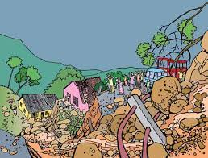
You are members of the National DRR Platform of Newland. Following the devastating landslides experienced earlier in the year, the DRR platform has successfully lobbied for the development of a comprehensive national disaster risk management law. This was based on the argument that the existing National Disaster Management Act is focused only on response and preparedness functions, without looking at reducing the underlying risk factors that lead to disasters in the first place.

A legislative drafting committee was recently established and it has requested a short presentation from the National DRR platform on what steps it should take, and what it should consider, to ensure that it addresses disaster risk reduction comprehensively when updating the legal framework and drafting a new, comprehensive law on disaster risk management. One member of the National DRR Platform will present their ideas to the committee, though the rest of the group will be on standby for support to the presenter if the committee asks any difficult questions.

In particular, the committee would like to know:

- What international standards does the new law need to conform with?
- What other information and existing laws need to be analysed before deciding on the focus and content of the new law?
- Since the national authorities have identified DRR as an important national priority for the coming years, what sort of provisions should the new law include to ensure DRR is effectively prioritised?
- How can the committee ensure that the new law will have an impact on the communities who are most affected by disasters in Newland?

